

Practical - Case Studies

SIS30315 Certificate III in Fitness –
Group Exercise
Name
Email address


© 2018 Australian Institute of Personal Trainers Pty Ltd and its licensors (AIPT) Commonwealth of Australia Copyright Regulations 1969
Warning
This material has been reproduced and communicated to you by or on behalf of AIPT, pursuant to Part VB of the Copyright Act 1968 (the Act).
The material in this communication may be subject to copyright under the Act. Any further reproduction or communication of this material by you may be the subject of copyright protection under the Act.
All rights are reserved and you must obtain the prior written permission of AIPT for the republication or redistribution of any content. Do not remove this notice.
Contents
Introduction 1
Course overview 2
Code of conduct policy 3
Case Study 1 - Roger Brown 4
Case Study 2 - Claudia Allen 15
Case Study 3 - Tom Jones 25
Case Study 4 - Children & Adolescents Group Training 35
Case Study 5 - Intermediate Exercise Group 38
Case Study 6 - Group Exercise Session 40

Introduction
Welcome to the SIS30315 Certificate III in Fitness - Group Exercise course. Before you begin please read through the following important information and commonly asked questions.

Units of competency

Certificate III requirements
Unit code | Unit title
SISFFIT004 | Incorporate anatomy and physiology principles into fitness programming
SISFFIT003 | Instruct fitness programs
SISXCCS001 | Provide quality service
SISFFIT001 | Provide health screening and fitness orientation
SISFFIT006 | Conduct fitness appraisals
SISFFIT005 | Provide healthy eating information
SISXFAC001 | Maintain equipment for activities
SISXIND001 | Work effectively in sport, fitness and recreation environments
SISFFIT002 | Recognise and apply exercise considerations for specific populations
SISFFIT014 | Instruct exercise to older clients
SISFFIT012 | Instruct movement programs to children aged 5 to 12 years
SISFFIT011 | Instruct approved community fitness programs
SISFFIT007 | Instruct group exercise sessions
HLTWHS001 | Participate in workplace health and safety
BSBRSK401 | Identify risk and apply risk management processes

Course overview
In order to complete the requirements for your Certificate III in Fitness – Group Exercise Instructor you are required to complete the following:
My eCampus Theory | - Assessments for each unit made up of Quizzes, and Assignments or Case studies
My eCampus Theory | - Six case studies to be completed and uploaded to My eCampus  - Roger Brown  - Claudia Allen  - Tom Jones  - Five Children (10-12 years old)  - Intermediate Group Session  - Pre-Choreographed Group
Structured Work Placement - Student logbook (Practical Logbook) | Practical placement logbook (minimum 30 hours)  a) Description of session/s content completed  b) Hours documented  c) Mentor initialled all sessions and signed logbook  d) Mentor included verification documents
Workplace Demonstration  (Two workplace demonstrations) | As part of the assessment for the units of competency, we are seeking additional evidence to support a judgement about the candidate’s competence. As part of the process of gathering evidence of competence, we will be seeking reports from your placement supervisor/industry professional.  Must complete and upload the following:  a) Organise a suitably qualified fitness professional to observe and comment on your ability to demonstrate relevant fitness skills in the workplace.  b) Organise an appropriate facility.  c) Organise someone to be your client.  d) Complete the two following workplace demonstrations.
Workplace Demonstration 1 | You will be required to conduct the following with a client:  a) General Preparation Activities  b) Client Screening  c) Fitness Appraisal  d) Warm-up  e) Conditioning Phase  f) Cool-down  g) Reviewing own performance, and identify areas potentially needing improvement
Workplace Demonstration 2 | a) Specific Populations  b) Children/community  c) Group exercise class

Code of conduct policy
The policy is designed to represent the expectations of the organisation and clearly establish behaviour guidelines and investigative procedures and consequences for inappropriate behaviour. The Student Code of Conduct is designed to uphold the dignity of all staff, students, and persons associated with the organisation. It sets out acceptable student behaviour and appropriate disciplinary measures. Its underlying purpose is to outline for students and staff their rights to work and study in a positive, secure, and orderly environment and show care, courtesy, and respect for the rights of others at all times.

Behaviour

Acceptable behaviour
- Being courteous, respectful, and well-mannered at all times
- Making responsible and thoughtful choices
- Being truthful, fair, caring, and considerate through actions and behaviour at all times
- Being professional in all dealings with staff and other students
- Participating actively and positively in learning at all times
- Respecting the rights of others to learn in a non-threatening environment
- Completing all assigned assessment tasks to the best of your ability
- Being on time for sessions

Unacceptable behaviour
- Swearing
- Plagiarism
- Fraud or any breach of the law
- Racial, religious, or sexual slurs towards staff or other students
- Threatening behaviour towards staff or other students
- Abuse
- Misuse of equipment
- Actions that lead to putting yourself, staff, or other students at risk
Any breach of the code of conduct will be investigated, and the student concerned will be asked to give a written response to these allegations. If it is found that a student has breached the code of conduct, then depending on the severity of the breach, that student may be given a warning or may even be terminated from the course without notice and receive no refund of fees. The CEO of the Australian Institute of Personal Trainers will make the final decision on any actions resulting in termination.

Case Study 1 - Roger Brown

Instructions
As the personal trainer, you will design a training plan for your client. Your clients name is Roger Brown.
1. Roger Brown has completed the Adults Pre-Exercise Screening Tool, AIPT Lifestyle Questionnaire, and the Fitness Appraisals. These documents are included in this assessment. With the information provided to you by Roger Brown, complete the following;
a. Healthy eating recommendations/advice
b. BMI rating and waist-to-hip ratio and rating
c. Appropriate questions
c. Complete a referral letter
d. Program, instruction, feedback

2. Using the attached templates, you will design a resistance training session. You will need to take into account the following:
a. Goal of the client
b. Address any medical issues and suggestions made by Roger’s allied health professional
c. Exercise order and selection to ensure a safe and effective program
d. Explain the benefits of exercise and the anticipated structural and physiological adaptation relevant to the client goals
e. Discuss client’s understanding of signs and symptoms of intolerance, precaution, and contra-indications to exercise

This session must include:
• Warm-up
• Conditioning phase
1. Balance activity
2. Coordination activity
3. Resistance (Compound exercise)
4. Resistance (Compound exercise)
5. Resistance (Compound exercise)
• Cool-down
Note:
• The program should be designed around a 30-minute training session.

Client Screening, AIPT lifestyle questionnaire, and Client Fitness Appraisal Pre-Filled Information

Completed Adult pre-exercise screening tool.
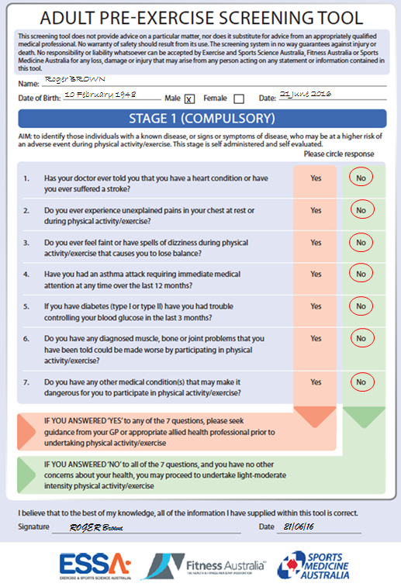
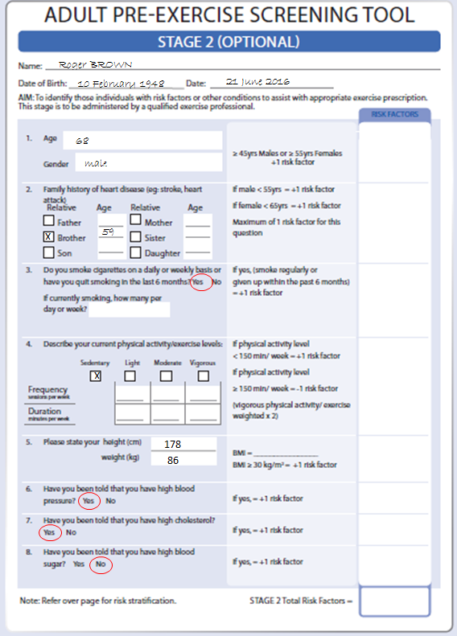

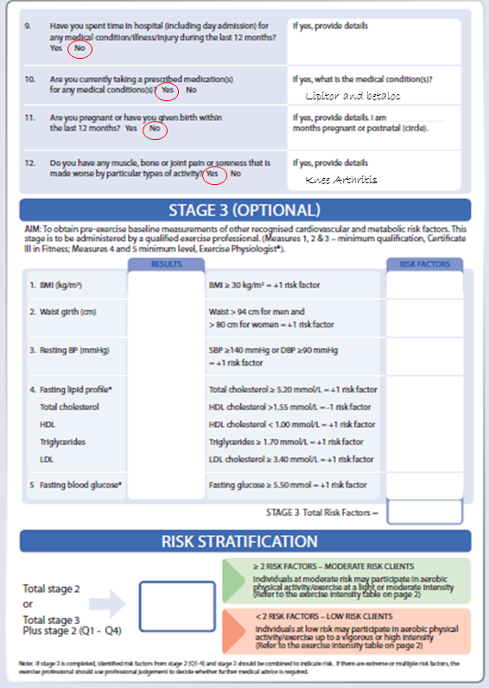

Completed AIPT lifestyle questionnaire (Confidential)
 | Name: | Roger Brown | Sex: |  | M/ F
 | Address: | 2 Sydney St, Sydney, 2005 | D.O.B |  | 10/02/1948
 | Tel: | 6892 0987 | Email: |  | Roger.brown@aipt.com
In can of emergency, whom can we contact? |  |  |  | Rose – 9873 0983
Occupation: please explain your position along with the physical and mental responsibilities involved
Owner of a newsagent

On a scale of 1 to 10 (1=not active, 10=very active) please rate how active you are on a daily basis.
1 | 2 | 3 | 4 | 5 | 6 | 7 | 8 | 9 | 10

How many hours’ sleep do you get every day? | 7 hrs
Are you currently involved in any exercise program? If yes, please list the duration, what type of exercises, and what intensity you participate at.
No

 | Goal setting
 | Please list three fitness /health-related goals (Using the SMART acronym)
 | Short | Start doing physical activity twice a week
 | Medium | Decrease my Blood Pressure and increase mobility
 | Long | Maintain blood pressure and decrease health risks
Where are you now in relation to your goal/s? |  |  | Haven’t started
What is the biggest challenge you must overcome in attaining your goal/s?
Pain my arthritis causes

On a scale of 1 to 10 (1=not committed, 10=very committed), please rate how committed you are to achieving your goal/s.
1 | 2 | 3 | 4 | 5 | 6 | 7 | 8 | 9 | 10

 | Training preferences
 | When do you prefer to exercise?
 | Before work | Lunch time |  | Afternoon |  | Evening
 | How many days can you train per week?
 | 1-2 | 2-3 |  | 3-4 |  | 4+
 | How long per session can you train?
 | <30 minutes |  | 30-45 minutes |  | 45-60 minutes
What type of exercise do you enjoy or prefer?
Walking and golf
Do you follow, or have you recently followed, any specific dietary intake plan and, in general, how do you feel about your nutritional habits?
No dietary plan followed

 | Daily dietary intake
 | Portions of milk/yoghurt/cheese: 5  Portions of vegetables/legumes/beans: 6  Portions of fruit: 4  Portions of meat/ poultry/ fish/ eggs/  tofu/ nuts/ seeds: 3  Portions of Grain (cereal) foods: 4  Glasses of water: 1 |  | Alcohol: 3  No. of cups of coffee/tea: 4  Glasses of Coke/Soda: 0  Sweets: 4  Other: _____________
 | Recommendations/ advice
All information on this form is correct to the best of my knowledge. I have sought and followed any necessary medical advice.
Signature: |  | Roger BROWN |  |  | Date: | 21/ 06/ 16

Completed Client fitness appraisal
Client name: | Roger Brown
Gender: | M | Date: | 21/ 06/ 16
D.O.B: | 10/ 02/ 1948 | Age: | 68
Height: | 178 cm | Weight: | 86 kg
BP: | 145 / 95 mm/Hg | RHR: | 90 beats/min
BMI: | 27.13 | BMI rating:

Girth measurement
Chest: | Blank cm | Arm: | Blank cm
Waist: | 120 cm | Hips: | 100 cm
Thigh: | Blank cm | Waist-to-hip ratio:
Waist/ hip rating: |  | RHR: | beats/min
Client feedback

Case Study Questions
1. Based on Roger’s food diary, provide Healthy eating recommendations/advice
2. Calculate Roger’s BMI and BMI rating
3. Identify Roger’s goals
4. Identify any medical conditions that should be communicated to a medical professional or allied health professional.
5. Explain the benefits of exercise and the anticipated structural and physiological adaptation relevant to the client goals.
6. List discussion points to ensure your client understands the signs and symptoms of intolerance, precaution, and contraindications to exercise.

Referral letter

Complete referral letter
Practitioner’s name: Fred Green
Clinic: Medical Centre
Address: Bold Head QLD 4000
Suburb, State, Postcode
Referral date: 21st July 2016
Dear Fred Green (practitioner’s name),
Re: Client name: Roger Brown
Client address:2 Sydney St, Sydney, 2005
Client DOB: 10/ 02/ 1948
My/our client Roger has presented to our business/service/facility with the following goals:

I am requesting your guidance in relation to his/her conditions of concern for medical clearance to enable me/us to ensure delivery of a safe and effective exercise program. Conditions identified:

I/we intend to have him/her commence an exercise program consisting of the following:

Yours sincerely,
Signature
Contact name:
Business name:
Phone number:
Email:


Dr Fred Green
Medical Cent re
Bold Head QLD 4000

Referral Date: 22nd June 2016
Dear Trainer,
Re: Client Name: Roger BROWN
Client Address: 2 Sydney St Sydney 2005
Client DOB: 10.02.1948

Thank you for referring your client Roger BROWN. I have given him clearance to participate in fitness activities. Based on Roger BROWN’s information and exercise program goals that you have supplied, my recommendations are:
Please avoid the following exercises due to his high blood pressure and arthritis:
• High impact
• Isometric movements
• High intensity
• Pushing above the head is not recommended

If I can assist with anything else, please don’t hesitate to contact me. Happy training!

Yours sincerely,
Fred Green
Fred Green
Medical Centre
Phone: 5555 5555
Email: fredgreen@medicalcentre.com

Program template

Complete program template
Client name: | Roger Brown |  |  |  | Client age: |  |  |  | 68 |  | Goal: |  |  |  | Decrease BP and improve mobility
Warm up
Conditioning phase
Exercise |  |  |  | Intensity |  |  | Sets | Reps |  |  |  | Rest period |  | Temp |  | Notes
Cool down
Notes for next session

Case Study 2 - Claudia Allen

Instructions
As the personal trainer, you will conduct a role play whereby you will be training a client over six weeks. Your client’s name is Claudia Allen.
1. Claudia has completed the Adults Pre-Exercise Screening Tool, AIPT Lifestyle Questionnaire, and the Fitness Appraisals. These documents are included in this assessment.
With the information provided to you by Claudia, complete the following:
a. Healthy eating recommendations/advice
b. BMI and BMI rating
c. Complete a referral letter
d. Program, instruction, feedback
e. What would you do after the completion of the six week program? What would you expect to see? Would you change anything based on reflection of the past six weeks moving forward into the next six week program?

2. Using the attached templates, you will design a resistance training session.
You will need to take into account the following:
a. Goal of the client
b. Address any medical issues and suggestions made by Claudia’s allied health professional
c. Exercise order and selection to ensure a safe and effective program

This session must include:
- Warm-up
- Conditioning phase:
a. Squat (or variation)
b. Pull (horizontal)
c. Push (horizontal)
d. Core/ torso
e. Resistance (Compound exercise)
- Cool-down

Note:
• The program should be designed around a 30-minute training session. There will also be 30 minutes allocated to demonstrate Claudia Allen’s session on a person of choice.
• For the purpose of this assessment, only demonstrate and instruct two sets of approx. 10-15 reps.

Client Screening, AIPT lifestyle questionnaire, and Client Fitness Appraisal Pre-Filled Information

Completed Adult pre-exercise screening tool.
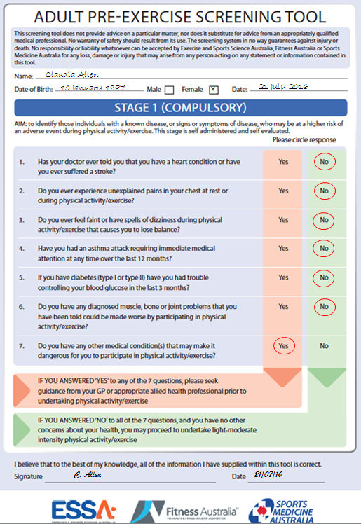
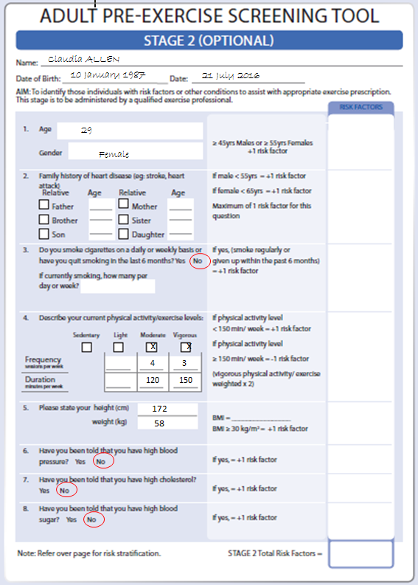

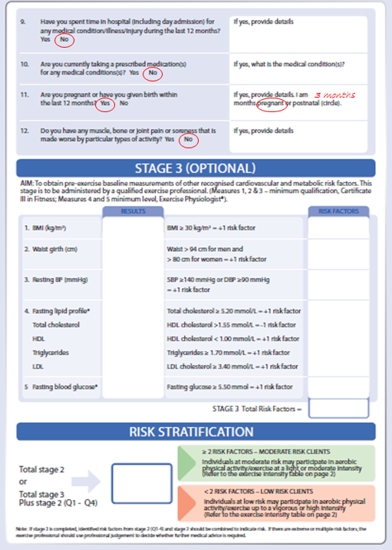

Completed AIPT lifestyle questionnaire (Confidential)
 | Name: | Claudia Allen | Sex: |  | M/ F
 | Address: | 55 Day Rd, Holt, ACT | D.O.B |  | 10/01/1987
 | Tel: | 1234 1234 | Email: |  | Claudia.allen@aipt.com
In can of emergency, whom can we contact? |  |  |  | Tom – 6789 6789
Occupation: please explain your position along with the physical and mental responsibilities involved
Human Resources

On a scale of 1 to 10 (1=not active, 10=very active) please rate how active you are on a daily basis.
1 | 2 | 3 | 4 | 5 | 6 | 7 | 8 | 9 | 10

How many hours’ sleep do you get every day? | 8 hrs
Are you currently involved in any exercise program? If yes, please list the duration, what type of exercises, and what intensity you participate at.
Yes, approx. 40mins, 7 times per week. Various from cycle classes, weights and running

 | Goal setting
 | Please list three fitness /health-related goals (Using the SMART acronym)
 | Short | Maintain fitness throughout pregnancy and reduce causes of back pain.
 | Medium | Have a smooth pregnancy
 | Long | Return to pre-pregnancy weight and training
Where are you now in relation to your goal/s? |  |  | Cut back sessions to 5 days a week instead of 7.
What is the biggest challenge you must overcome in attaining your goal/s?

On a scale of 1 to 10 (1=not committed, 10=very committed), please rate how committed you are to achieving your goal/s.
 | 1 | 2 | 3 |  | 4 |  | 5 | 6 | 7 |  | 8 |  | 9 | 10
 | Training preferences
 | When do you prefer to exercise?
 | Before work |  |  | Lunch time |  |  |  | Afternoon |  |  |  | Evening
 | How many days can you train per week?
 | 1-2 |  |  | 2-3 |  |  |  | 3-4 |  |  |  | 4+
 | How long per session can you train?
 | <30 minutes |  |  |  |  | 30-45 minutes |  |  |  | 45-60 minutes
What type of exercise do you enjoy or prefer?
Cycling, running, weights
Do you follow, or have you recently followed, any specific dietary intake plan and, in general, how do you feel about your nutritional habits?
No dietary plan followed. However, I am gluten intolerant.

 | Daily dietary intake
 | Portions of milk/yoghurt/cheese: 5  Portions of vegetables/legumes/beans: 6  Portions of fruit: 5  Portions of meat/ poultry/ fish/ eggs/  tofu/ nuts/ seeds: 3  Portions of Grain (cereal) foods: 4  Glasses of water: 6 |  |  | Alcohol: 0  No. of cups of coffee/tea: 2  Glasses of Coke/Soda: 0  Sweets: 0  Other: _____________
 | Recommendations/ advice
All information on this form is correct to the best of my knowledge. I have sought and followed any necessary medical advice.
Signature: |  | Claudia Allen |  |  | Date: | 21/ 06/ 16

Completed Client fitness appraisal
Client name: | Claudia Allen
Gender: | F | Date: | 21/ 07/ 16
D.O.B: | 10/ 01/ 1987 | Age: | 29
Height: | 172 cm | Weight: | 58 kg
BP: | 119 / 80 mm/Hg | RHR: | 60 beats/min
BMI: |  | BMI rating:

Girth measurement
Chest: | 83 cm | Arm: | 34 cm
Waist: | 65 cm | Hips: | 74 cm
Thigh: | 48 cm | Waist-to-hip ratio: | Blank
Blood Pressure: | 119/80 mm/Hg | RHR: | 65 beats/min
Client feedback

Case Study Questions
1. Based on Claudia’s food diary, provide Healthy eating recommendations/advice

2. Calculate Claudia’s BMI and BMI rating

3. Identify Claudia’s goals

4. Identify any medical conditions that should be communicated to a medical professional or allied health professional.

Complete referral letter
Practitioner’s Details
Name: Robert Tune
Clinic: Medical Centre
Address: Bold Head ACT 3099
Referral date: 21st July 2016
Dear (practitioner’s name),
Re: Client name: Claudia Allen
Client address:55 Day Rd, Holt, ACT
Client DOB: 10/ 01/ 1987
My/our client Claudia Allen has presented to our business/service/facility with the following goals:

I am requesting your guidance in relation to his/her conditions of concern for medical clearance to enable me/us to ensure delivery of a safe and effective exercise program. Conditions identified:

I/we intend to have him/her commence an exercise program consisting of the following:

Yours sincerely,
Signature
Contact name:
Business name:
Phone number:
Email:

Dr Robert Tune
Medical Centre
Bold Head ACT 3099

Referral Date: 22nd July 2016

Dear Trainer,

Re: Client Name: Claudia Allen
Client Address: 55 Day Rd, Holt ACT
Client DOB: 10.01.1987

Thank you for referring your client Claudia Allen. I have given her clearance to participate in fitness activities. Based on Claudia ALLEN’S information and exercise program goals that you have supplied, my recommendations are:
Please avoid the following exercises due to her pregnancy:
• High impact exercises
• High intensity (HR above 130bpm)
• Avoid exercise that requires lying on your back
• Avoid bouncing exercises
• Appropriate exercises modifications to be made as pregnancy progresses

If I can assist with anything else, please don’t hesitate to contact me. Happy training!

Yours sincerely,
Robert Tune

Robert Tune
Medical Centre
Phone: 5555 5555
Email: Robert.tune@medicalcentre.com

Program template

Complete the program template
Client name: | Claudia Allen |  | Client age: |  | 29 |  | Goal: |  | Good health through pregnancy (now 3 months)
Warm up
Conditioning phase
Exercise |  |  | Intensity | Sets |  | Reps |  | Rest period |  | Temp | Notes
Cool down
Notes for next session

Case Study 3 - Tom Jones

Instructions
As a personal trainer, you will conduct a role play where you will be the trainer. Your client’s name is Tom Jones.
1. Tom Jones has completed the Adults Pre-Exercise Screening Tool, AIPT Lifestyle Questionnaire, Fitness Appraisals, and a Referral Response letter from his AHP. These documents are included in this assessment.
With the information provided to you by Tom Jones, complete the following:
a. Complete a referral letter
b. Flexibility program to promote ideal posture.

2. Using the attached templates, you will design a flexibility session.
You will need to take into account the following:
a. Goal of the client
b. Address any medical issues and suggestions made by Tom’s allied health professional
c. Exercise order and selection to ensure a safe and effective program

This session must include:
a. Four upper-body and four lower-body stretches including dynamic/ static (partner)
b. *Optional – PNF stretching
c. Muscles to consider: (Gastrocnemius, Soleus, Quadriceps group, Hamstring group, Psoas, Gluteus Maximus, Rectus Abdominus, Erector Spinae, Latissimus Dorsi, Trapezius(upper/middle/lower), Rhomboids, Pectorals, Deltoid, etc.)
Note: The program should be designed around a 30-minute training session.

Client Screening, AIPT lifestyle questionnaire, and Client Fitness Appraisal Pre-Filled Information

Completed Adult pre-exercise screening tool
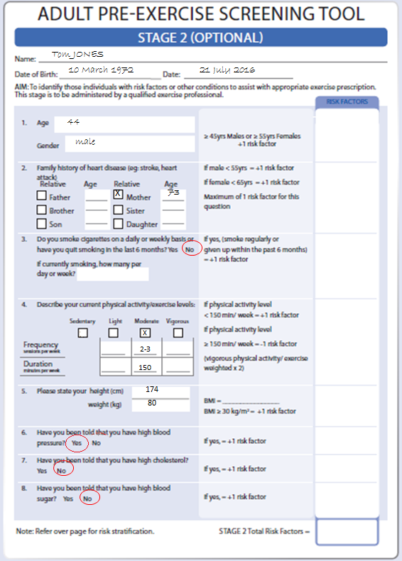
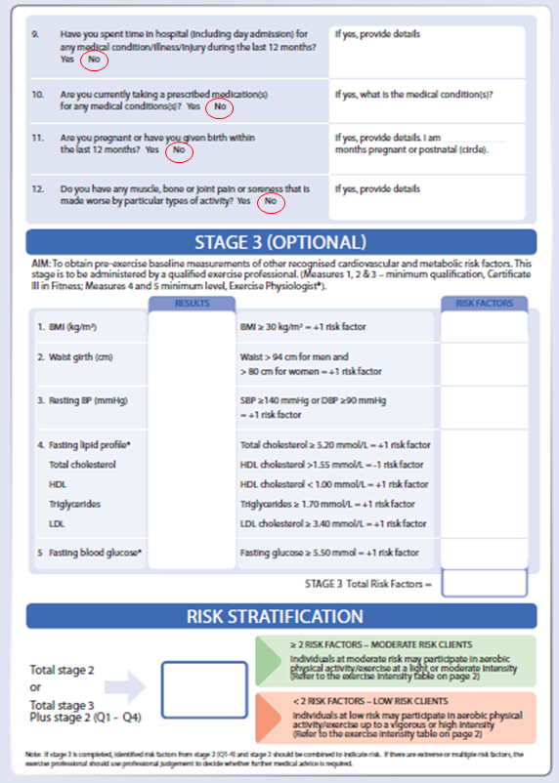

Completed AIPT lifestyle questionnaire (Confidential)
 | Name: | Tom Jones | Sex: |  | M/ F
 | Address: | 201 Kite Cres, Hume, WA | D.O.B |  | 10/03/1972
 | Tel: | 9756 0786 | Email: |  | Tom.jones@aipt.com
In can of emergency, whom can we contact?
Occupation: please explain your position along with the physical and mental responsibilities involved
IT program developer

On a scale of 1 to 10 (1=not active, 10=very active) please rate how active you are on a daily basis.
1 | 2 | 3 | 4 | 5 | 6 |  | 7 | 8 | 9 | 10
How many hours’ sleep do you get every day? |  |  |  |  |  | 6 hrs
Are you currently involved in any exercise program? If yes, please list the duration, what type of exercises, and what intensity you participate at.
No

 | Goal setting
 | Please list three fitness /health-related goals (Using the SMART acronym)
 | Short | Increase health and fitness. Increase flexibility through hamstrings, lower back and chest.
 | Medium | Run 5km and work on flexibility
 | Long | Run City to City 10km race and continue to improve flexibility
Where are you now in relation to your goal/s? |  |  | Have started stretching 1 time a week.
What is the biggest challenge you must overcome in attaining your goal/s?
Lacking time as work commitments are long.

On a scale of 1 to 10 (1=not committed, 10=very committed), please rate how committed you are to achieving your goal/s.
1 | 2 | 3 | 4 | 5 | 6 | 7 | 8 | 9 | 10

 | Training preferences
 | When do you prefer to exercise?
 | Before work | Lunch time |  | Afternoon |  | Evening
 | How many days can you train per week?
 | 1-2 | 2-3 |  | 3-4 |  | 4+
 | How long per session can you train?
 | <30 minutes |  | 30-45 minutes |  | 45-60 minutes
What type of exercise do you enjoy or prefer?
Running, weights, boxing
Do you follow, or have you recently followed any specific dietary intake plan and, in general, how do you feel about your nutritional habits?
No dietary plan followed.

 | Daily dietary intake
 | Portions of milk/yoghurt/cheese: 2  Portions of vegetables/legumes/beans: 1  Portions of fruit: 3  Portions of meat/ poultry/ fish/ eggs/  tofu/ nuts/ seeds: 5  Portions of Grain (cereal) foods: 4  Glasses of water: 6 |  | Alcohol: 4  No. of cups of coffee/tea: 4  Glasses of Coke/Soda: 2  Sweets: 3  Other: _____________
 | Recommendations/ advice
All information on this form is correct to the best of my knowledge. I have sought and followed any necessary medical advice.
Signature: |  | Tom Jones |  |  | Date: | 21/ 07/ 16

Completed Client fitness appraisal
Client name: | Tom Jones
Gender: | M | Date: | 21/ 07/ 16
D.O.B: | 10/ 03/ 1972 | Age: | 44
Height: | 174 cm | Weight: | 80 kg
BP: | 145 / 80 mm/Hg | RHR: | 60 beats/min
BMI: | 26.4 | BMI rating:

Girth measurement
Chest: | Blank cm |  | Arm: | Blank cm
Waist: | Blank cm |  | Hips: | Blank cm
Thigh: | Blank cm |  | Waist-to-hip ratio: | Blank
Waist/ hip rating: | Blank |  | RHR: | beats/min
Client feedback
Has High Blood Pressure, therefore will require a medical clearance. He also is in the overweight range for his BMI rating, which needs improving with incidental exercise.
Start with flexibility and include some aerobic exercises.

Mobility |  |  | Other
Test: |  | Sit and reach | Test:
Result: |  | - 15 | Result:
Rating: |  | Poor | Rating:
Feedback/ recommendations |  |  | Feedback/ recommendations
Needs to work on hamstring and lower-back flexibility.

Case Study Questions
1. Based on Tom’s food diary, provide Healthy eating recommendations/advice
2. Calculate Tom’s BMI and BMI rating
3. Identify Tom’s goals

4. Identify any medical conditions that should be communicated to a medical professional or allied health professional.
5. Explain the benefits of exercise and the anticipated structural and physiological adaptation relevant to the client goals.
6. List discussion points to ensure your client understands the signs and symptoms of intolerance, precaution, and contraindications to exercise.

Complete referral letter
Practitioner’s name: Melanie Smooth
Clinic: Medical Centre
Address: Happy Valley WA 4000

Referral date: 21st July 2016
Dear Melanie Smooth (practitioner’s name),
Re: Client name: Tom Jones
Client address:201 Kite Cres, Hume, WA
Client DOB: 10/ 03/ 1972
My/our client Tom has presented to our business/service/facility with the following goals:

I am requesting your guidance in relation to his/her conditions of concern for medical clearance to enable me/us to ensure delivery of a safe and effective exercise program. Conditions identified:

I/we intend to have him/her commence an exercise program consisting of the following:

Yours sincerely,
Signature
Contact name:
Business name:
Phone number:
Email:

Dr Melanie Smooth
Medical Centre
Happy Valley WA 4000

Referral Date: 22nd July 2016

Dear Trainer,

Re: Client Name: Tom Jones
Client Address: 201 Kite Cres, Hume, WA
Client DOB: 10.03.1972

Thank you for referring your client Tom Jones. I have given him clearance to participate in fitness activities. Based on Tom Jones’s information and exercise program goals that you have supplied, you are able to prescribe Tom any variety of exercises but with gradual progression.

If I can assist with anything else, please don’t hesitate to contact me. Happy training!
Yours sincerely,
Melanie Smooth

Melanie Smooth
Medical Centre
Phone: 5555 5555
Email: melanie.smooth@medical centre.com

Flexibility program template – This can vary with hamstring, abdominal strengthening and aerobic conditioning.

Complete the flexibility program template
Client name: |  | Tom Jones |  |  |  | Client age: |  | 44 |  | Goal: |  | Flexibility to promote ideal posture
 | Warm up
 | Conditioning phase
 | Exercise |  | Intensity |  | Sets |  | Reps |  | Rest period |  | Temp |  | Notes
 | Cool down
 | Notes for next session

Case Study 4 - Children & Adolescents Group Training

Instructions
As the personal trainer, you will design training for two groups of five children in the age groups of 8-10 and 12-13 year olds.
1. The community healthy lifestyle program you will be running is called Healthy, Active, Happy, Kids. It is designed to educate and positively impact children in relation to nutrition, physical activity, personal improvement, and fun games. The program is conducted over two hours.
2. You will need to take into account the following:
a. Target audience
b. One child has mild case of asthma
c. WHS of your environment
d. Exercise/activity order and selection to ensure a safe and effective program
3. Using the attached template, design a community program.

This session must include:
a. Warm-up
b. Conditioning section
Minimum of five stations/activities (each station/activity requires a progression and regression)
c. Cool-down

Activity program template

Complete the activity program template: 8-10 year olds
Group name: |  |  |  |  | Group age: |  |  |  |  | Goal:
Warm up
Conditioning phase
Exercise/ activity |  | Intensity |  | Sets |  | Reps |  |  | Rest period |  |  | Temp | Notes
Cool down
Notes for next session

Activity program template

Complete the activity program template: 12-13 year olds
Group name: |  |  |  |  |  |  | Group age: |  |  |  |  |  | Goal:
Warm up
Conditioning phase
Exercise/ activity |  |  | Intensity | Sets |  |  |  | Reps |  |  | Rest period |  |  |  | Temp |  | Notes
Cool down
Notes for next session

Case Study 5 - Intermediate Exercise Group

Instructions
In this task, you will need to undertake the following:
You are the personal trainer, you will be training a group of clients that are at an intermediate exercise level. The session should be designed as a 45 minute session. The group has conducted individual pre-exercise screening and the following has been identified:
• Female client (age 45) with minimal English (English as a second language). No contraindications to exercise.
• Female client (age 36), no contraindications to exercise.
• Female client (age 24), broken leg 3 years ago with minimal participation in exercise since. Medical clearance provided and no ongoing issues.
• Male client (31) with previous knee injury and has been given clearance to recommence training.
• Male client (40) with previous shoulder reconstruction (8 years ago) and has been given clearance to recommence training.
• Male client (25), no contraindications to exercise.

1. Using the attached template, you will then design your resistance circuit. You will need to take into account the following:
- Target audience
- WHS for your environment
- Exercise/activity order and selection to ensure a safe and effective program
2. Lastly, preparation for clients not being able to perform an exercise or exercises in your original circuit program due to injury or pain.
- Suggest a regression exercise for all exercises of your original circuit. E.g. Pull-up > Lat Pull Down.

Circuit program template

Complete the circuit program template
Session objective: |  |  |  |  |  | Target audience:
Duration: |  |  |  |  |  | No. of circuit repeats:
Working intervals: |  |  |  |  |  | Rest intervals:
Equipment:
Warm up
Conditioning phase
Station |  | Progression | Regression |  | Main circuit diagram
Cool down
Notes for next session

Case Study 6 - Group Exercise Session

Instructions
You have been requested to design a 60 minute group fitness class. The timeframe allows for pre-class interaction and group pre-screening, set-up and safety check of equipment, and group feedback after the class.
1. As a group fitness instructor, you will design a class for a group of participants.
2. Your class will be ‘an exercise to music’ class, using choreography (no pre-choreography). Consider the following in your delivery:
- Phasing of the workout, beats per min, rhythm, add-on and layering, 32-count phrase and realistic timings of the choreography
- Music that matches the participant group and style of class
3. Using the below template, design a full 60 minute session that will cater for a wide variety of clients with different needs, fitness levels and abilities.
4. Your session must include a demonstration of:
- Work health and safety and duty of care requirements
- Group pre-screening
- Clear pre-session instructions
- Activities and exercises that cater for a wide variety of participants
- Examples of modification and progression so as to show that you can make exercises harder/easier depending on the level and needs of the client
- High and low-impact activities
- Choreography that matches the beat and timing of the music and needs of the participants
- Motivational techniques to support and encourage your clients

Group fitness class plan

Complete the group fitness class plan
Class name: |  |  |  |  |  | Duration: |  | 60 minutes
Description of class: |  |  |  |  |  | Style of music:
Equipment list:
Pre-class instructions:
 | Exercise description |  | Bets | Repetition |  |  | Count |  | Modification | Progression
Warm-up | e.g. Step touch |  | 4 | 4 |  |  | 16 |  | March OTS | Pony
Conditioning
Cool-down

